CUSTOMER CHURN PREDICTION & LTV ENGINE

Week 4 Progress Report

Prepared By:
Archita Jar

Internship Domain:
Data Analytics

Date:
8 July 2026

Week 4 Objectives
- Deploy the Customer Churn Prediction application using FastAPI and Docker.
- Integrate the PostgreSQL database with the application.
- Test API endpoints using Swagger UI.
- Develop an interactive dashboard using Metabase.
- Prepare deployment and project documentation for final submission.

Project Workflow
Dataset
│
▼
PostgreSQL Database
│
▼
Feature Engineering
│
▼
Machine Learning Models
(Random Forest,
Linear Regression)
│
▼
FastAPI
│
▼
Swagger UI (API Testing)│
▼
Visualization
(Metabase)

Work Completed
1. Docker Deployment
- Created a Dockerfile for containerizing the FastAPI application.
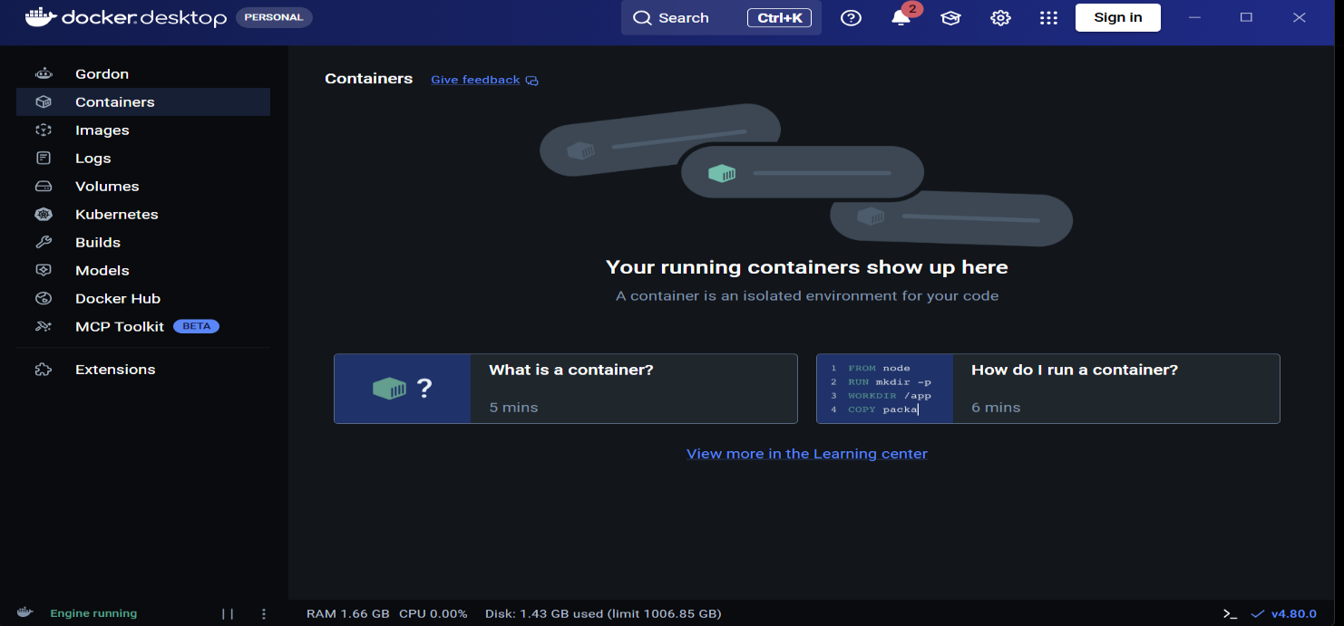
- Configured docker-compose.yml to manage application services.
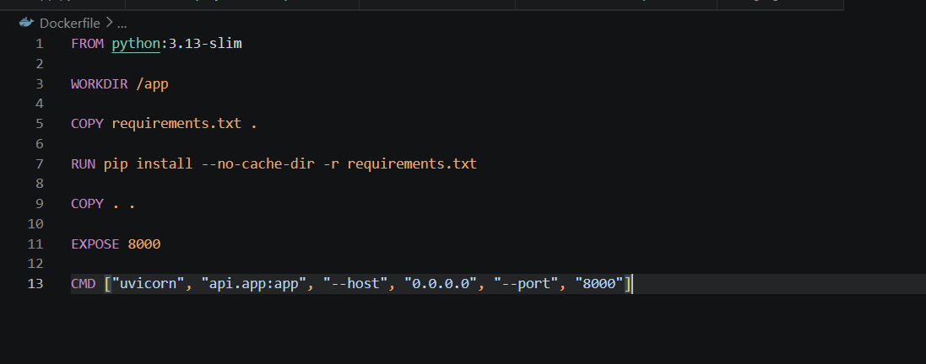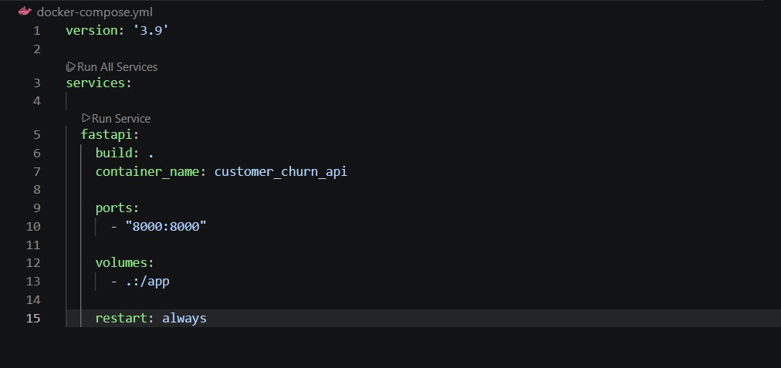
- Successfully built and started Docker containers.
- Verified that the application was running correctly inside the Docker environment.

2. FastAPI Application Deployment
- Successfully deployed the Customer Churn Prediction application using FastAPI.
- Verified API functionality through Swagger UI.
- Tested the following API endpoints:
  - /predict – Predicts churn for a single customer.
  - /batch_predict – Predicts churn for multiple customers using a CSV file.
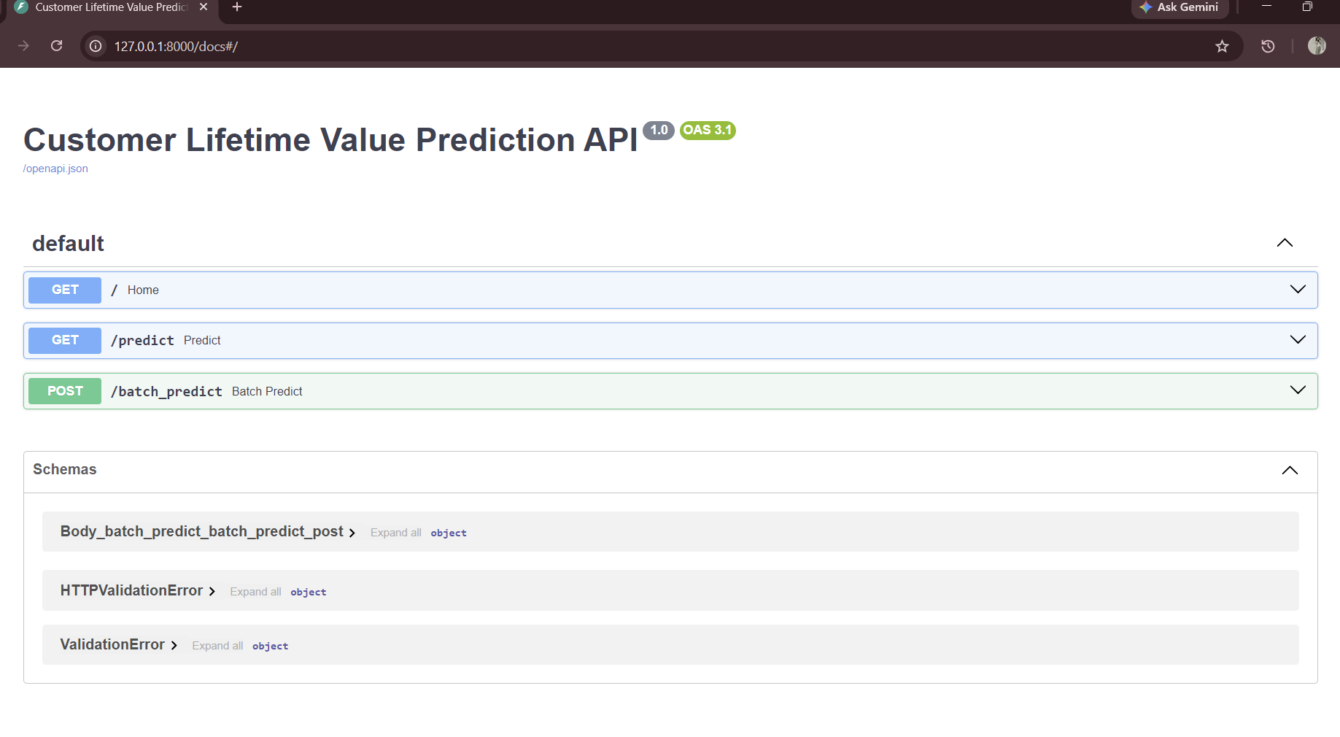

3. PostgreSQL Database Integration
- Connected the FastAPI application to the PostgreSQL database.
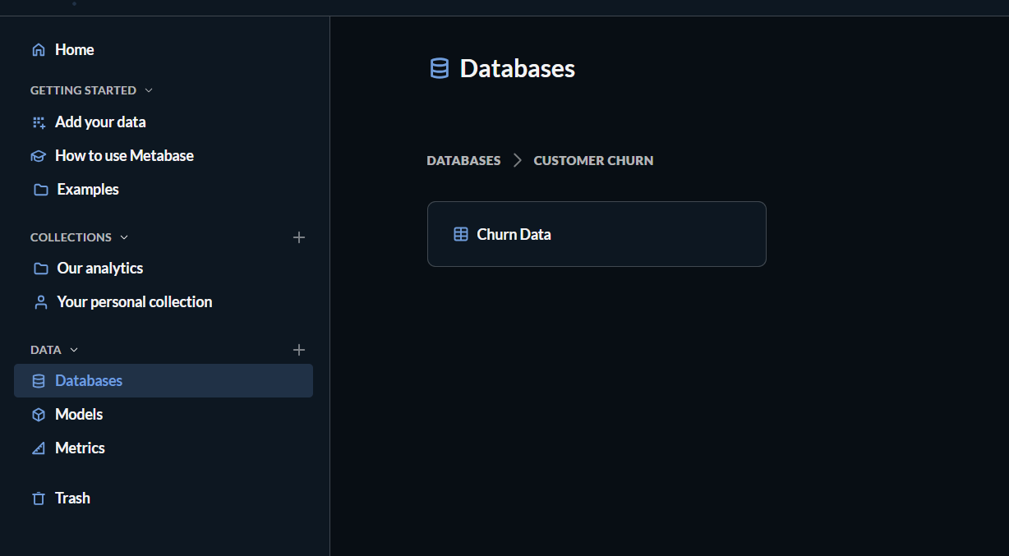
- Verified successful database connectivity.
- Confirmed that the Customer Churn dataset was successfully detected and accessible within Metabase.
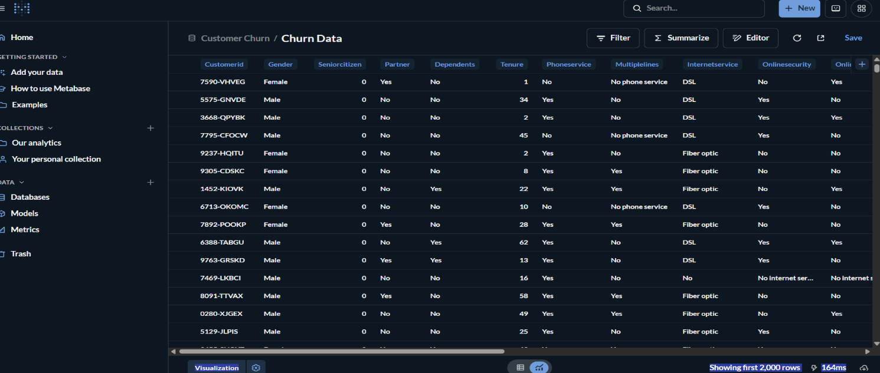

4. Metabase Dashboard Development
Designed and developed an interactive Customer Churn Dashboard for business analysis.
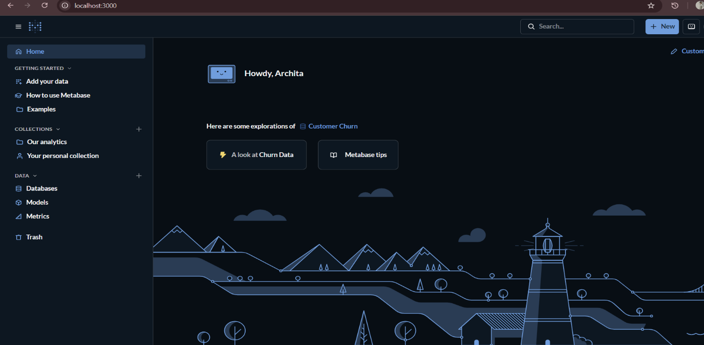
KPI Cards
- Total Customers
- Churned Customers
- Retained Customers
- Churn Percentage
Interactive Dashboard Filters
- Tenure
- Gender
- Contract
- Churn Status
Visualizations
- Churn Distribution
- Customers by Gender
- Customers by Contract
- Customers by Payment Method
- Customers by Internet Service
- Customers by Senior Citizen
- Customers by Paperless Billing
- Customers by Dependents
- Customers by Partner
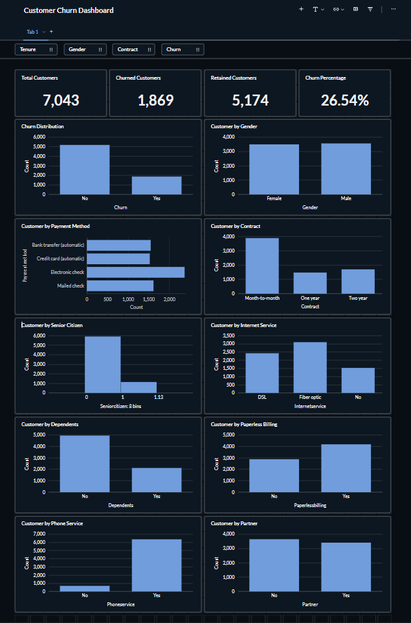
The dashboard provides business insights through KPI cards, interactive filters, and visualizations, enabling users to explore customer churn patterns dynamically. These visualizations help analyze customer behaviour and identify factors influencing customer churn.

5. Project Documentation
Created comprehensive documentation covering:
- Deployment setup
- Docker setup
- Visualization setup
- Dashboard planning
- SQL queries used for dashboard creation
- Dashboard documentation
- Deployment notes
- Overall project summary

Deliverables
The following project components were successfully completed during Week 4:
- Dockerfile
- docker-compose.yml
- FastAPI Application
- Swagger UI Testing
- PostgreSQL Integration
- Interactive Metabase Dashboard
- Dashboard SQL Queries
- Deployment Documentation
- Updated README
- Week 4 Project Screenshots

Technologies Used
- Python
- FastAPI
- PostgreSQL
- SQLAlchemy
- Docker
- Docker Compose
- Metabase
- Swagger UI
- Git & GitHub

Challenges Faced
- Faced Docker configuration issues during deployment.
- Resolved API and PostgreSQL database connectivity problems.
- Successfully configured Metabase and connected it with PostgreSQL.
- Designed and refined an interactive dashboard with KPI cards, charts, and filters.

Outcome
By the end of Week 4, the Customer Churn Prediction and Customer Lifetime Value (LTV) Analysis project was successfully deployed using FastAPI and Docker. The application was integrated with PostgreSQL, API endpoints were tested through Swagger UI, and an interactive Metabase dashboard was developed featuring KPI cards, filters, and business visualizations. The deployment files, documentation, and project structure were finalized, making the project ready for demonstration and final submission.

